CERTIFICATION

I N D I G E N T

TO WHOM IT MAY CONCERN:

This is to certify that , years old, , is a resident of Barangay 192, with postal address at Street Bo. Obrero Tondo Manila.
This further certifies that the subject person concerned is known to us that belong to the INDIGENT FAMILY of this Barangay. Their family have no sufficient income and barely enough to meet day to day needs.
This certification was issued upon the request of the above-mentioned person .
IN WITNESS WHEREOF I have hereunto set my hand and affixed the official seal of this office.
Issued in the Office of the Barangay Chairman, Barangay 192 Zone 17 District II this th day of , City of Manila.

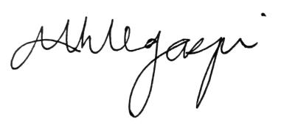

MARIA MAGDALENA H. LEGASPI
CHAIRWOMAN

